Unit 1. Feelings and Opinion
Guía n° 1 English Language

Nombre: |  |  |  | Curso: | 7th | Fecha
Puntaje Evaluación |  |  | Puntaje de corte (60%):
Puntaje obtenido: |  |  | Calificación:

INSTRUCCIONES:
- No se podrá entregar la guía sin estar resuelta completamente.
- La guía puede ser resuelta con apoyo de un diccionario. No está permitido copiar trabajos de otros compañeros/as.
- La guía debe ser entregada el día Martes 7 de Abril

Objetivos: Comprensión lectora
Contenidos: Vocabulario relacionado a emociones y sentimientos

I. Feelings and Emotions
how does Bart and his friends feel?
Bored | Hungry | Sorprised | 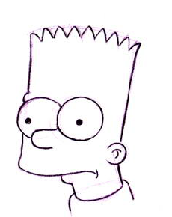  Confused
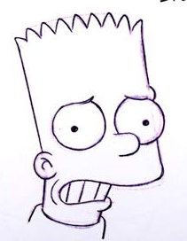  Worried |   Scared |   Excited | Happy
  Shy |   Thirsty | 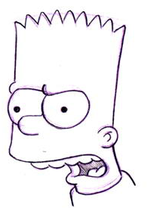  Angry | 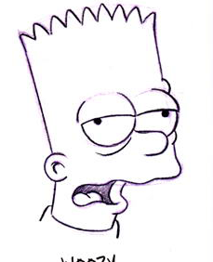  Tired
  Sleepy |   In love |   Heart broken | 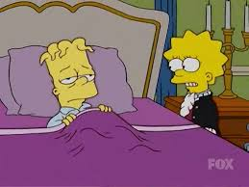  Sick

II. Examples
Bart is scared | 
Bart is sleepy | 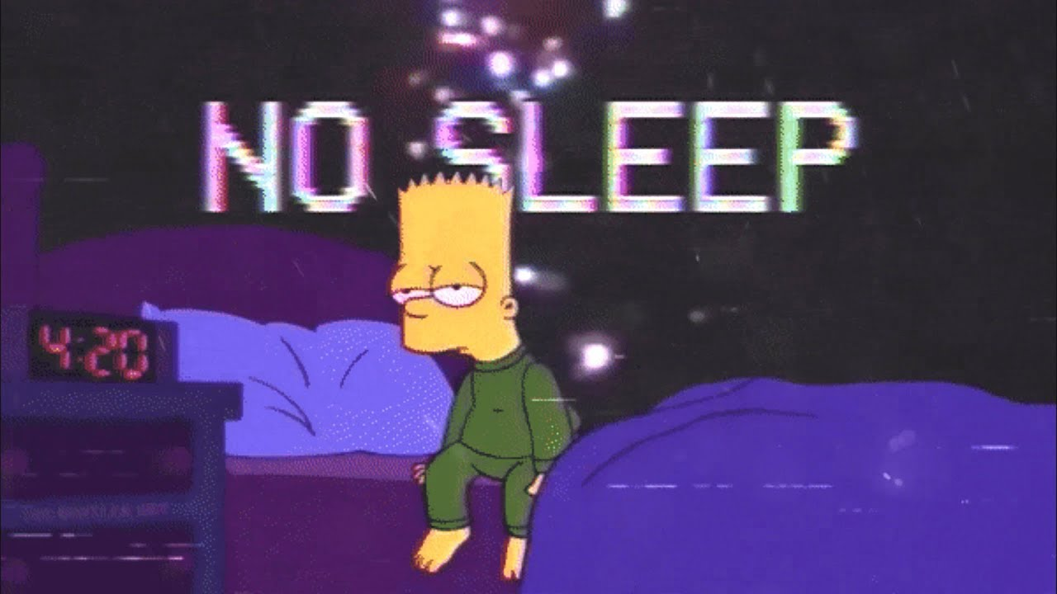
Ralph is heart broken | 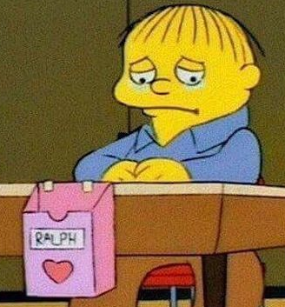
Lisa is in love | 
Videos: https://www.youtube.com/watch?v=7uY2HrQ9qQ8&t=1s
Feelings and Emotions Vocabulary

III Exercises

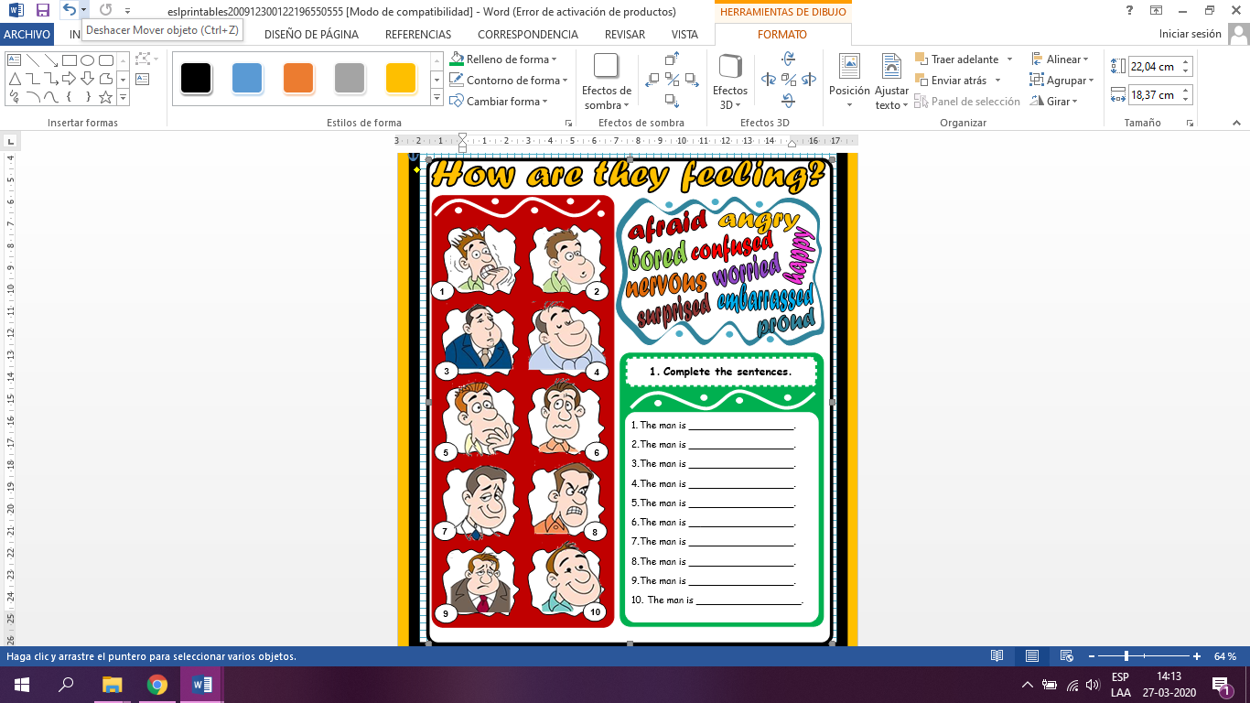
A. Complete the sentences.
The man is __________________.
The man is __________________.
The man is __________________.
The man is __________________.
The man is __________________.
The man is __________________.
The man is __________________.
The man is __________________.
The man is __________________.
The man is __________________.

A. READ the following text. UNDERLINE the feelings you find In it.
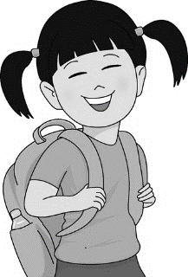
On Monday I went to school and felt really excited because I had my favorite Art lesson. I couldn’t wait to finish my painting. When I finished I gave it to my friend as a gift.
On Tuesday I forgot my lunch so I was really hungry at lunchtime. I didn’t have any money to buy anything from the kiosk.
On Wednesday I had a very important test so I was really nervous. I really wanted to get a good grade. It was a Maths test.
On Thursday it was a really hot day and didn’t bring my water bottle with me. I was really thirsty.
On Thursday my friends forgot to take me to the table tennis club. I was sad that I had to stay on my own. I couldn’t find them anywhere so I read a book in the classroom.
On Friday when I came back home at 4 o’clock my mum took me to the seaside and bought me a massive cake. I was so surprised! I didn’t expect it. It was a lovely day!
Saturday was a really busy day. I went shopping with my mum, then went to the cinema with my friend and helped my younger sister with her homework. At 9.30 I was really sleepy and went to bed at 10 o’clock.
On Sunday it was my cousin’s birthday party which started at 4 o’clock. At 6 o’clock we all went ice skating and I was so scared that I would fall.

B. WRITE the feelings here.
-----------------------------------------------------------------------------------------------------------------------------------------------------------------------------------------------------------------------------------------------------------------------------------------------------------------------------------------------------------------------------------------------------------------------------------------------------------------------------------------------------------------------------------------------------------------


C. ANSWER the following questions about the text.

a.) How did she feel on Monday?
-----------------------------------------------------------------------------------------------------------------------------------------------------------------------------------------------------------------------------------------------------------------------------------------------------------------------------------------------------------------------------------------------------------------------------------------------------------------------------------------------------------------------------------------------------------------

b.) What did she do with her painting?
-----------------------------------------------------------------------------------------------------------------------------------------------------------------------------------------------------------------------------------------------------------------------------------------------------------------------------------------------------------------------------------------------------------------------------------------------------------------------------------------------------------------------------------------------------------------

c.) Why was she hungry on Tuesday?
-----------------------------------------------------------------------------------------------------------------------------------------------------------------------------------------------------------------------------------------------------------------------------------------------------------------------------------------------------------------------------------------------------------------------------------------------------------------------------------------------------------------------------------------------------------------

d.) Why couldn’t she buy anything from the canteen?
-----------------------------------------------------------------------------------------------------------------------------------------------------------------------------------------------------------------------------------------------------------------------------------------------------------------------------------------------------------------------------------------------------------------------------------------------------------------------------------------------------------------------------------------------------------------

e.) What test did she have on Wednesday?
-----------------------------------------------------------------------------------------------------------------------------------------------------------------------------------------------------------------------------------------------------------------------------------------------------------------------------------------------------------------------------------------------------------------------------------------------------------------------------------------------------------------------------------------------------------------

f.) How did the test make her feel?
-----------------------------------------------------------------------------------------------------------------------------------------------------------------------------------------------------------------------------------------------------------------------------------------------------------------------------------------------------------------------------------------------------------------------------------------------------------------------------------------------------------------------------------------------------------------

D. Make a summary of the text you read. WRITE your ideas here in four lines.
-----------------------------------------------------------------------------------------------------------------------------------------------------------------------------------------------------------------------------------------------------------------------------------------------------------------------------------------------------------------------------------------------------------------------------------------------------------------------------------------------------------------------------------------------------------------

E. WRITE two questions about general ideas from the text. Make your questions to a classmate.
a) -----------------------------------------------------------------------------------------------------------------------------------b) ------------------------------------------------------------------------------------------------------------------------------------

F. WRITE one activity the girl from the text does each day.

a) Monday:
b) Tuesday:
c) Wednesday:
d) Thursday:
e) Friday:
f) Saturday:
g) Sunday:
G. What characteristics of the girl can you identify in the text? WRITE them here.
-----------------------------------------------------------------------------------------------------------------------------------------------------------------------------------------------------------------------------------------------------------------------------------------------------------------------------------------------------------------------------------------------------------------------------------------------------------------------------------------------------------------------------------------------------------------

